**Program 1:**

**import** java.util.Scanner;

**public** **class** sample {

**public** **static** **void** main(String[] args) {

System.***out***.print("Enter a number ");

Scanner sc=**new** Scanner(System.***in***);

**int** n = sc.nextInt();

**if**(n>0) {

System.***out***.println("Number is positive");

}

**else** **if**(n<0) {

System.***out***.println("Number is negative");

}

**else** {

System.***out***.println("Number is zero");

}

}

OUTPUT:

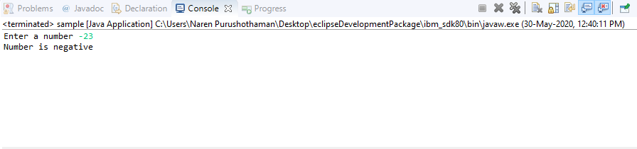

____________________________________________________________

PROGRAM 2:

**import** java.util.Scanner;

**public** **class** sample {

**public** **static** **void** main(String[] args) {

System.***out***.print("Enter a number ");

Scanner sc=**new** Scanner(System.***in***);

**int** n = sc.nextInt();

**if**(n%2==0) {

System.***out***.println("Number is even");

}

**else** {

System.***out***.println("Number is odd");

}

}

}

OUTPUT:

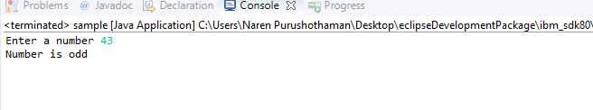

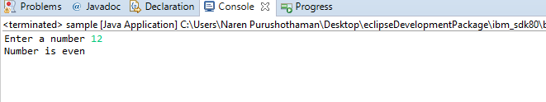

______________________________________________________________________

PROGRAM 3:

**public** **class** sample1 {

**public** **static** **void** main(String[] args) {

**if** (args.length ==0)

{

System.***out***.println("No Values");

}

**else**{

**for**(String i : args) //for each value in args store in i

System.***out***.print(i+" , ");}

}

}

OUTPUT:

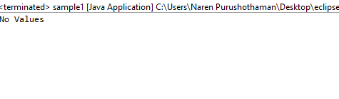

_____________________________________________________________________________________

PROGRAM 4:

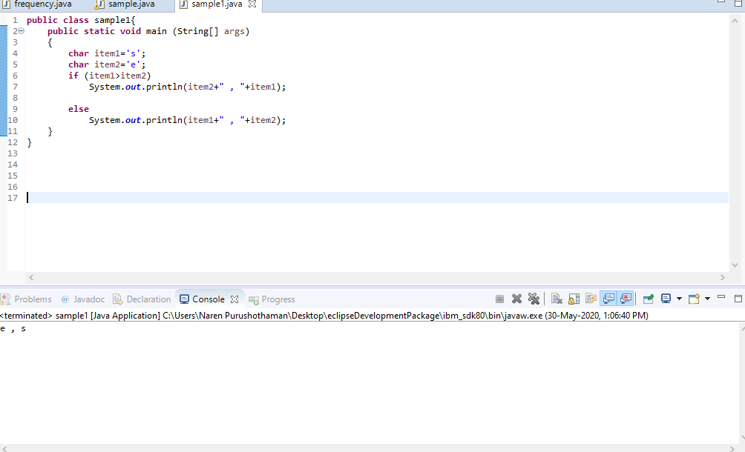

Same program with input given as a and e

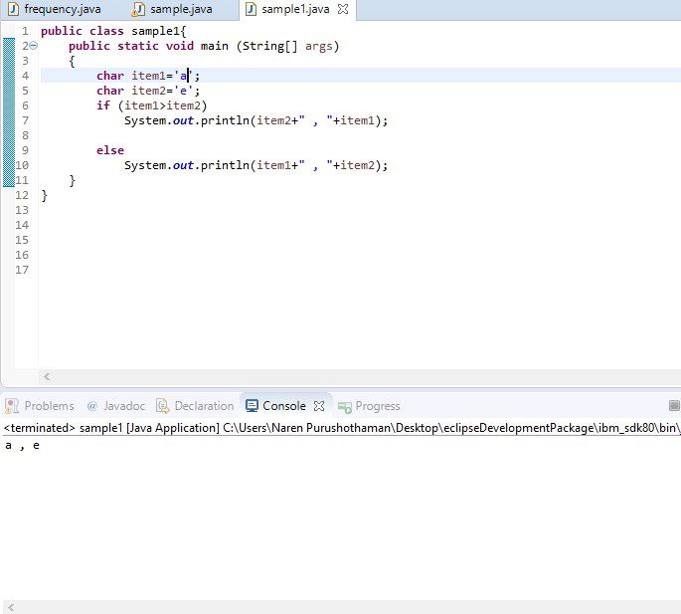

_______________________________________________________________

PROGRAM 5:

**import** java.io.*;

**public** **class** sample2 {

**static** **void** charCheck(**char** input_char)

{

**if** ((input_char >= 65 && input_char <= 90)

|| (input_char >= 97 && input_char <= 122))

System.***out***.println(" Alphabet ");

**else** **if** (input_char >= 48 && input_char <= 57)

System.***out***.println(" Digit ");

**else**

System.***out***.println(" Special Character ");

}

**public** **static** **void** main(String[] args)

{

**char** input_char = 'A';

**char** input_char2 = '4';

**char** input_char3 = '$';

*charCheck*(input_char);

*charCheck*(input_char2);

*charCheck*(input_char3);

}

}

OUTPUT:

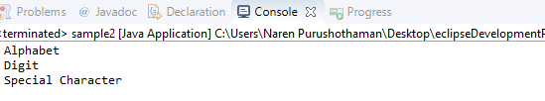_________________________________________________________________

PROGRAM 6:

**public** **class** sample4 {

**public** **static** **void** main(String[] args) {

String gender = args[0];

**int** age=Integer.*parseInt*(args[1]);

**if**(gender.equals("Female")) {

**if**(age>=1 && age<=58) {

System.***out***.println("Interest= 8.2%");

}

**else** **if**(age>58 && age<=120) {

System.***out***.println("Interest=7.6%");

}

}

**else** {

**if**(age>=1 && age<=60) {

System.***out***.println("Interest=9.2%");

}

**else** **if**(age>60 && age<=120) {

System.***out***.println("Interest at 8.3%");

}

}

}

}

OUTPUT:



PROGRAM 7:

**import** java.util.Scanner;

**public** **class** sample5 {

**private** **static** Scanner *sc*;

**public** **static** **void** main(String[]args) {

*sc* = **new** Scanner(System.***in***);

**char** c=*sc*.next().charAt(0);

**int** temp;

**if**(c>='a'&& c<='z') {

System.***out***.println(c+"->");

temp=(**int**)c;

c=(**char**)(temp-32);

System.***out***.println(c);

}

**else** {

System.***out***.println(c+"->");

temp=(**int**)c;

c=(**char**)(temp+32);

System.***out***.println(c);

}

}

OUTPUT:

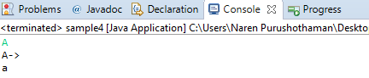

PROGRAM 8:

**public** **class** sample6 {

**public** **static** **void** main(String[] args) {

**char** ch=args[0].charAt(0);

**switch**(ch) {

**case** 'R':

System.***out***.println("R->RED");

**break**;

**case** 'G':

System.***out***.println("G->GREEN");

**break**;

**case** 'B':

System.***out***.println("B->BLUE");

**break**;

**case** 'O':

System.***out***.println("O->ORANGE");

**break**;

**case** 'Y':

System.***out***.println("Y->YELLOW");

**break**;

**case** 'W':

System.***out***.println("W->WHITE");

**break**;

**default**:

System.***out***.println("INVALID CHOICE");

}

}

}

OUTPUT:

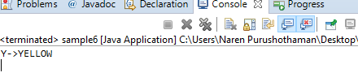

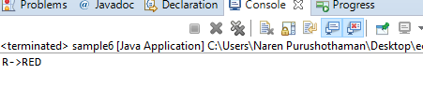

PROGRAM 9:

**public** **class** sample7 {

**public** **static** **void** main(String args[]) {

System.***out***.println("Enter a number to get month");

**int** ch;

ch=Integer.*parseInt*(args[0]);

**switch**(ch) {

**case** 1:

System.***out***.println("JANUARY");

**break**;

**case** 2:

System.***out***.println("FEBRUARY");

**break**;

**case** 3:

System.***out***.println("MARCH");

**break**;

**case** 4:

System.***out***.println("APRIL");

**break**;

**case** 5:

System.***out***.println("MAY");

**break**;

**case** 6:

System.***out***.println("JUNE");

**break**;

**case** 7:

System.***out***.println("JULY");

**break**;

**case** 8:

System.***out***.println("AUGUST");

**break**;

**case** 9:

System.***out***.println("SEPTEMBER");

**break**;

**case** 10:

System.***out***.println("OCTOBER");

**break**;

**case** 11:

System.***out***.println("NOVEMBER");

**break**;

**case** 12:

System.***out***.println("DECEMBER");

**break**;

**default**:

System.***out***.println("INVALID CHOICE");

**break**;

}

}

}

OUTPUT:

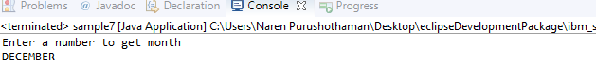

­­­­­­­­­­­­­­­­­­­

PROGRAM 10:

**public** **class** forloop {

**public** **static** **void** main(String[] args) {

**for** (**int** i=1;i<=10;i++) {

System.***out***.println(i);

}

}

}

OUTPUT:

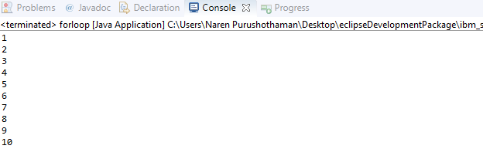

PROGRAM 11:

**public** **class** sample8 {

**public** **static** **void** main(String[] args) {

// **TODO** Auto-generated method stub

**for**(**int** i=23;i<=57;i++) {

**if**(i%2==0) {

System.***out***.println(i);

}

}

OUTPUT:

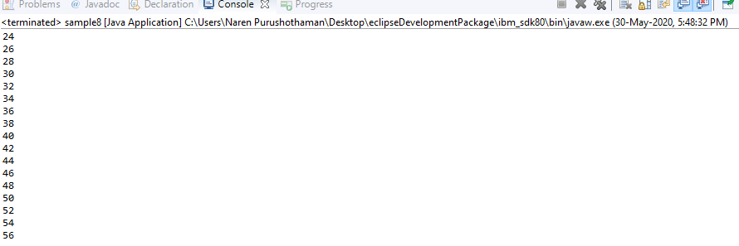

PROGRAM 12:

**public** **class** PrimeNumber{

**static** **void** checkPrime(**int** n){

**int** i,m=0,flag=0;

m=n/2;

**if**(n==0||n==1){

System.***out***.println(n+" is not prime number");

}**else**{

**for**(i=2;i<=m;i++){

**if**(n%i==0){

System.***out***.println(n+" is not prime number");

flag=1;

**break**;

}

}

**if**(flag==0) { System.***out***.println(n+" is prime number"); }

}

}

**public** **static** **void** main(String args[]){

*checkPrime*(7);

*checkPrime*(44);

}

}

OUTPUT:

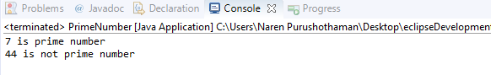

PROGRAM 13:

**import** java.util.Scanner;

**public** **class** PrimeNo2 {

// driver code

**public** **static** **void** main(String[] args)

{

Scanner sc = **new** Scanner(System.***in***);

**int** a, b, i, j, flag;

System.***out***.printf("Enter lower bound of the interval: ");

a = sc.nextInt(); // Take input

System.***out***.printf("\nEnter upper bound of the interval: ");

b = sc.nextInt(); // Take input

System.***out***.printf("\nPrime numbers between %d and %d are: ", a, b);

**for** (i = a; i <= b; i++) {

**if** (i == 1 || i == 0)

**continue**;

flag = 1;

**for** (j = 2; j <= i / 2; ++j) {

**if** (i % j == 0) {

flag = 0;

**break**;

}

}

**if** (flag == 1)

System.***out***.println(i);

}

}

}

OUTPUT:

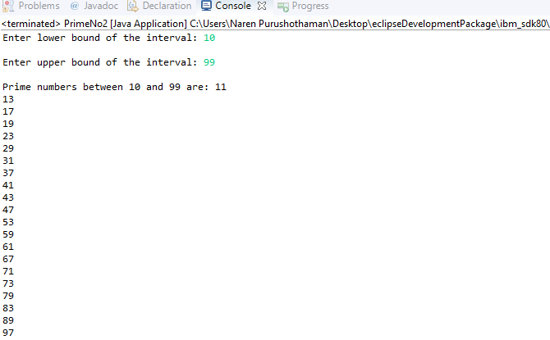

PROGRAM 14:

**public** **class** primecmd {

**public** **static** **int** isPrime(**int** x)

{

**int** i;

**for** (i = 2; i < x / 2 + 1; i++) {

**if** (x % i == 0) {

**return** 0;

}

}

**return** 1;

}

**public** **static** **void** main(String[] args)

{

**if** (args.length > 0) {

**int** n = Integer.*parseInt*(args[0]);

**if** (*isPrime*(n) == 1)

System.***out***.println("Its a prime number");

**else**

System.***out***.println("Not a prime number");

}

**else**

System.***out***.println("No command line "

+ "arguments found.");

}

}

OUTPUT:



PROGRAM 15:

**import** java.util.Scanner;

**public** **class** AddDigits {

**public** **static** **void** main(String[] args) {

// **TODO** Auto-generated method stub

System.***out***.println("Enter a number ");

Scanner sc=**new** Scanner(System.***in***);

**int** n=sc.nextInt();

**int** rem,val=0;

**while**(n!=0) {

rem=n%10;

val=val+rem;

n=n/10;

}

System.***out***.println(val);

}

}

OUTPUT:

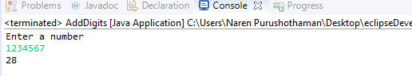

PROGRAM 16:

**public** **class** Floyds {

**public** **static** **void** main(String[] args) {

**int** n=Integer.*parseInt*(args[0]);

**for**(**int** i=0;i<n;i++) {

**for**(**int** j=0;j<=i;j++) {

System.***out***.print("* ");

}

System.***out***.println();

}

}

}

OUTPUT:

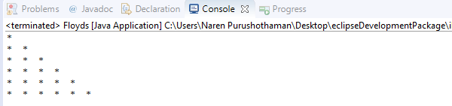

PROGRAM 17:

**import** java.util.Scanner;

**public** **class** ReversedNum {

**public** **static** **void** main(String[] args) {

System.***out***.println("Enter a number ");

Scanner sc = **new** Scanner(System.***in***);

**int** num=sc.nextInt();

**int** rev=0;

**while**(num!=0) {

**int** digits=num % 10;

rev=rev * 10+digits;

num=num/10;

}

System.***out***.println("Reversed number = " +rev);

}

}

OUTPUT:

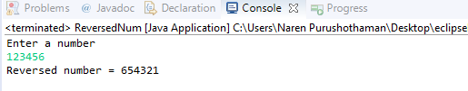

PROGRAM 18:

**import** java.util.Scanner;

**public** **class** Palindrome {

**public** **static** **void** main(String[] args)

{

System.***out***.println("Enter a number : ");

**int** num = **new** Scanner(System.***in***).nextInt();

**int** number=num;

**int** rev=0;

**while** (number != 0)

{

**int** rem = number % 10;

rev = rev * 10 + rem;

number = number / 10;

}

**if**(num == rev) {

System.***out***.println("it is a Palindrome number");

}

**else** {

System.***out***.println("it is Not a Palindrome number");

}

}

}

OUTPUT:

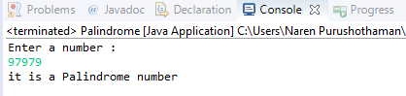

PROGRAM 19:

**public** **class** Division {

**public** **static** **void** main(String[] args) {

**int** count=0,i=1;

**while**(count<5) {

**if**(i%2==0 && i%3==0 && i%5==0) {

System.***out***.println(i);

count++ ;

}

i++ ;

}

}

}

OUTPUT:

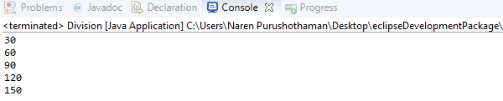

PROGRAM 20:

**import** java.util.Scanner;

**public** **class** AddSub {

**public** **static** **void** main(String args[]){

System.***out***.println("1.ADDITION\n2.SUBTRACTION");

Scanner sc=**new** Scanner(System.***in***);

**int** choice= sc.nextInt();

System.***out***.println("Enter two operands ");

**int** operand1 = sc.nextInt();

**int** operand2 = sc.nextInt();

**int** result=0;

**switch**(choice) {

**case** 1:

result = operand1 + operand2;

System.***out***.println("Result = "+result);

**break**;

**case** 2:

result = operand1 - operand2;

System.***out***.println("Result = "+result);

**break**;

}

System.***out***.println("Do you want to continue or not? Y or N");

sc.nextLine();

choice = sc.nextLine().charAt(0);

sc.close();

}

}

OUTPUT:

